Torque Mode:

Joint state configuration →
endpoint.pose
endpoint.header.stamp
end_pointstate_pub.publisher(endpoint)

Takes a joinststate message and uses a callback to return the desired endpoint pose and the final timestamp
Retrieves the appropriate forward kinematics from the joint states (posestamped)

The initialized topic is /robot/limb/left/endpoint_state topic
However there is no twist or wrench information on the topic because they were never implemented

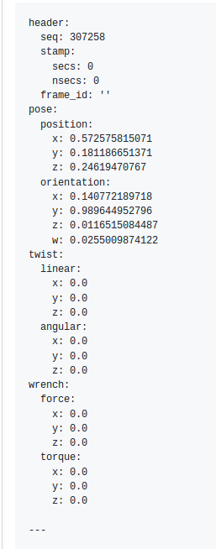

https://github.com/RethinkRobotics/baxter_simulator/blob/master/baxter_sim_kinematics/src/position_kinematics.cpp#L120-L134

https://github.com/RethinkRobotics/baxter_simulator/issues/44

Rosbag to matlab:

To format the rosbag_to_matlab codeline here is an example

rosrun rosbag_to_matlab bag_to_mat.py example.bag src/

in order for this to run properly you MUST have cd to the directory where your bag files exist
at the current time I do not have the <output directory> section working (src/) when I run this line of code I seem to run into errors.

